Angie’s Rock Room

PUBLISHER: ARR Productions Volume No. 1 Issue No. 1 Date March 2003
Angie’s
Rock Room

Angie’s Rock Room is a place for news and information on your favorite bands of today and yesterday. I am just a music lover who wants to spread the word on what is good in music.
In the coming issues, we will discuss the best new bands on to the scene as well as give you up dates on some of the bands that radio have seem to forgotten.

“Gods and Guitars”

The summer of 2003 is heating up once again. After three years Metallica is back on the road this summer with the “Summer Sanitarium 2003 Tour”. As their newest album “St. Anger” is due out on June 10, the long awaited album has been reported to be getting back to the basics. That means the Old SCHOOL METALLICA is back and ready to kick major ass! That’s why the re-release of the vintage t-shirt “metal up your ass” has been worth the wait. One of the bands most sought after t-shirts, it was first offered to its club members. There will be plenty of those shirts surfing through the stadiums this summer as the band does a major city tour with Linkin Park, Limp Bizkit, Mudvayne and the Deftones.
Speaking of Old School, Def Leppard is back on the road this summer in support of their latest album “X”. Also called “Ten”, the band is even playing on the bill at the “Rolling Rock Town Festival” With the first single “Now”

getting little or no airtime from radio stations, the band will set fire to fans with a fury of new songs and old favorites. WWW.DefLeppard.com has tour dates and up to date information.

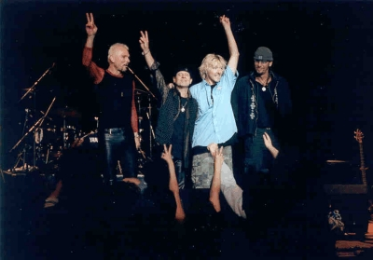
The Scorpions!
Are also on tour. Joining them on the tour are Whitesnake and Dokken. Playing big cities and small towns, the band is in support of their album “Bad for Good” The Hurricane is still blowing for the guys from Germany.
Ozzfest 2003 is coming to a city near you. All the freaks and festivities will start early again this summer as the “Prince of Darkness” and his band of merry men embark tour across the country. The only question is who will be playing bass as Ozzy’s former bassist Rob Trujillo has joined Metallica as the fourth member of the band. Metallica’s former bassist Jason Newstead has reportedly asked to audition for the gig. Baring any unforeseen events; this years Ozzfest has been billed to be one of the best of the summer. Ozzy Osbourne, Korn, Disturbed, Marilyn Manson, Chevelle and Trust Company. Plus...Cradle of Filth, Voivod & 12 more bands on the 2nd stage! www.Ozzfest.com
Comments or suggestions: angelofmetallica@hotmail.com

